

Linton Primary School - EYFS

All About Me!
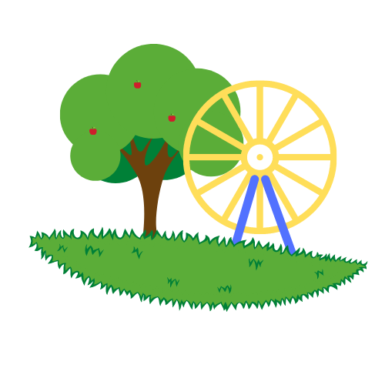

Please complete and email to
CRowley@linton.derbyshire.sch.uk
or drop it off at the school office.

My name is_________________________________
Please attach a photo!
My birthday is ______________________________
I like to be called____________________________
I live with __________________________________
Their contact number is _______________________
Email Address _________________________________________________
Other important people are________________________________________
______________________________________________________________
My brothers and sisters are called__________________________________
______________________________________________________________
I have pet/s called ______________________________________________
______________________________________________________________
At home I enjoy________________________________________________
At home I don’t like_____________________________________________
Nursery Rhymes I know are _____________________________________________________________
My favourite toy is______________________________________________
My favourite book is_____________________________________________

The things I like to play or play with are
__________________________________________________________________________________________________________________________________________________________________________________________
I’m really interested in
_________________________________________________________________________________________________________________________________________________________________________________________
Things I don’t like or I’m scared of are
_________________________________________________________________________________________________________________________________________________________________________________________
I can use a knife and fork independently if I am having a hot dinner at school Yes/No

I might need help with toileting dressing and undressing (please circle as appropriate or add anything else you feel we should be aware of)
___________________________________________________________________________________________________________________________

Things I would like you to know about are ________________________________________________________________________________________________________________________________________________________________________________________________________________________________________________________
Questions I would like answered are __________________________________________________________________________________________________________________________________________________________________________________________
I have allergies to, or medical issues of
____________________________________________________________________________________________________________________________
I take regular medication of _______________________________________ for ___________________________________________________________
*Please note if medication needs to be taken you will be asked to fill in a permission form.
Illness I have had are, for example, chicken pox - _____________________
______________________________________________________________
The names of the speech therapist/ health visitor/paediatrician I see regularly (if any) is __________________________________________________
I have had an eye test on _________ and my optician said ______________
I have had a hearing test on ________ and they said ___________________

I go to a child minders and their name is ____________________________
Their contact details are
______________________________________________________________
______________________________________________________________
______________________________________________________________
I have/ have not been to another early years setting or nursery.
If you have please provide a name and contact details below.
______________________________________________________________
______________________________________________________________

Please make a list of people that may pick your child up from your child’s class. The relationship between child and adult would also be helpful.
______________________________________________________________
______________________________________________________________
______________________________________________________________
______________________________________________________________
______________________________________________________________

The person who has overall parental responsibility is Mum/Dad/Both/Other (please specify below)
______________________________________________________________
______________________________________________________________
A password will be asked for when an adult, other than the known people, pick up your child from school. Please write the password below.
____________________________________________________________
Is there any other information you would like to share with us?
______________________________________________________________
______________________________________________________________
______________________________________________________________
______________________________________________________________

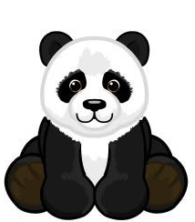
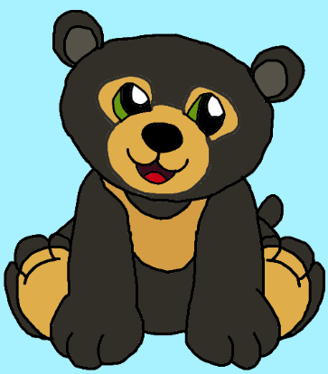
Thank you! This information will help the EYFS staff to get to know your child. The EYFS Staff will try to answer any questions and are available at the beginning and end of each session if you have any concerns.

